Access Plan of SAHELIS Productions
Ouagadougou – Burkina Faso

Map of Ouagadougou
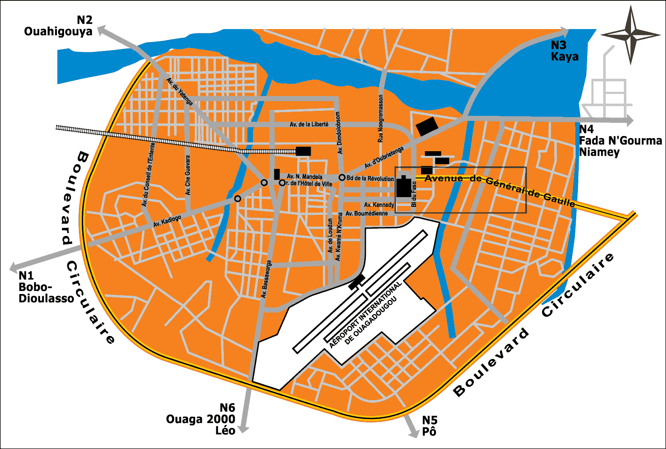

Enlarging
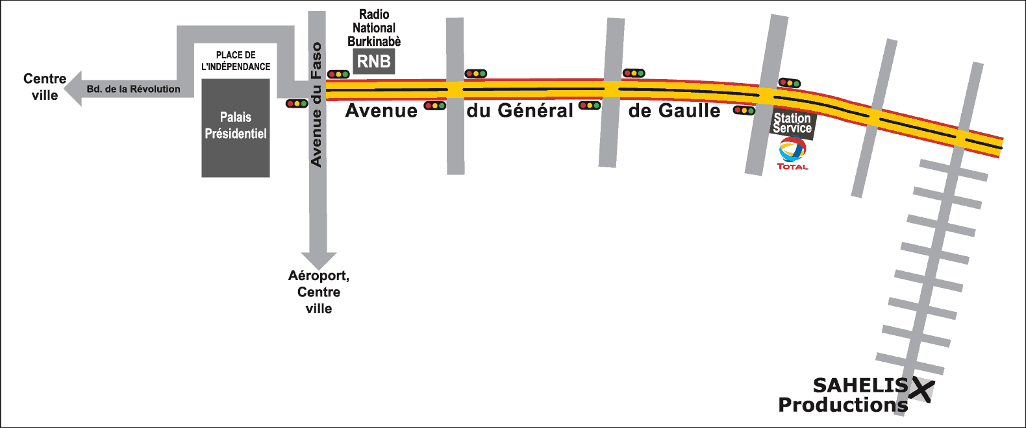

Behind the President Office, take Avenue du General De Gaulle.
Continue on this Avenue over about 1.8 km.
After the 3rd left (near the filling Station), take the 2nd street on the right.

Go right on over 600 meters. Sahelis is on your left just after the 8th crossroads from Avenue du General De Gaulle. Welcome !

Any problem ? Feel free to call us. Our telephone number is + (226) 50 36 30 33

L'équipe SAHELIS Productions

